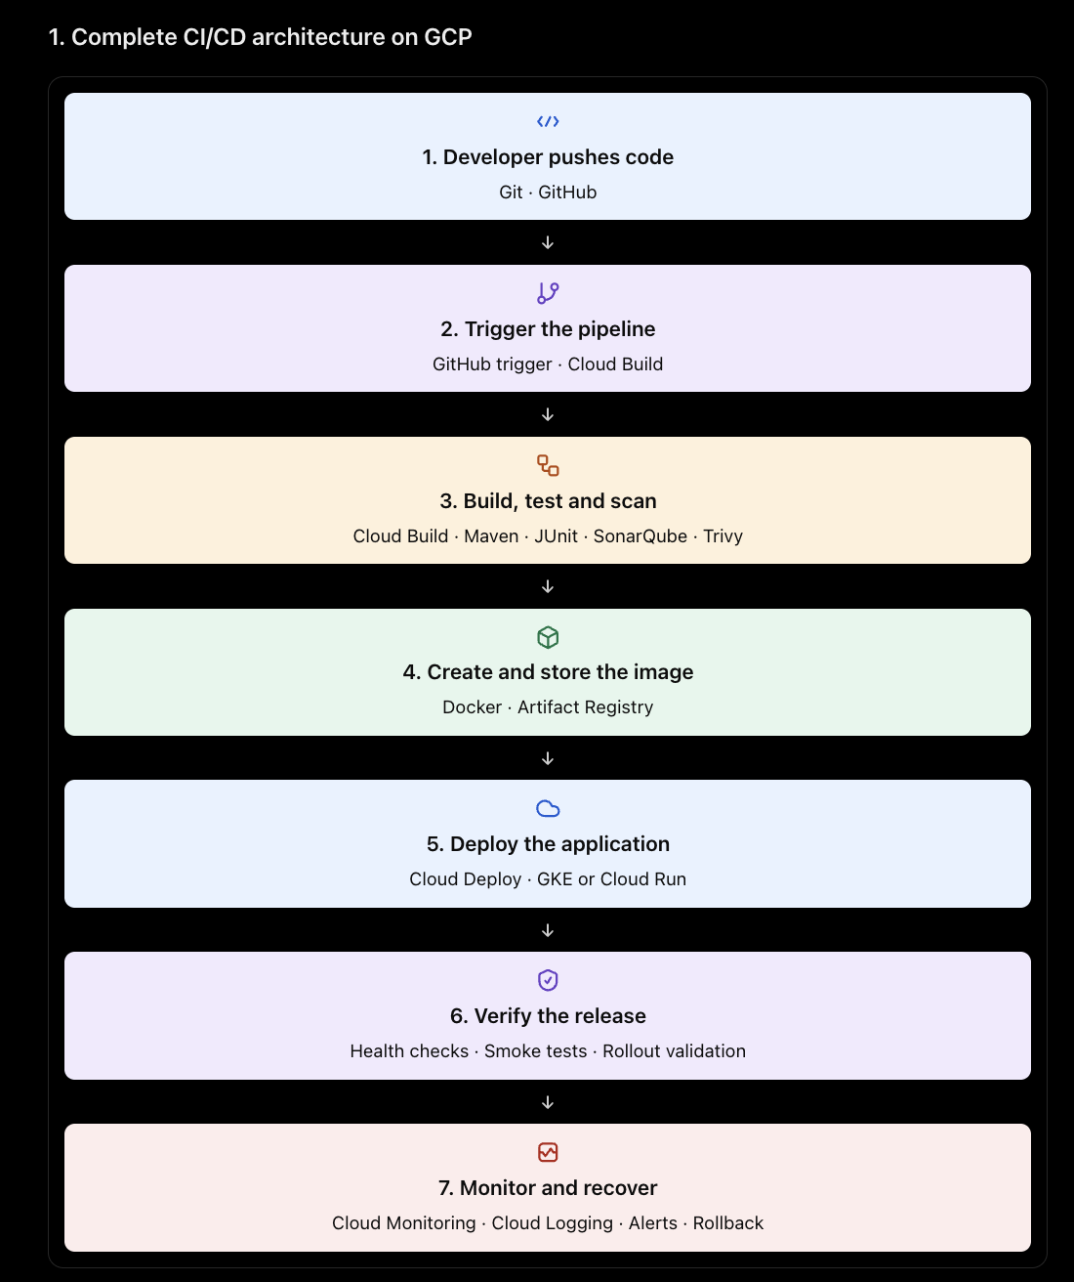
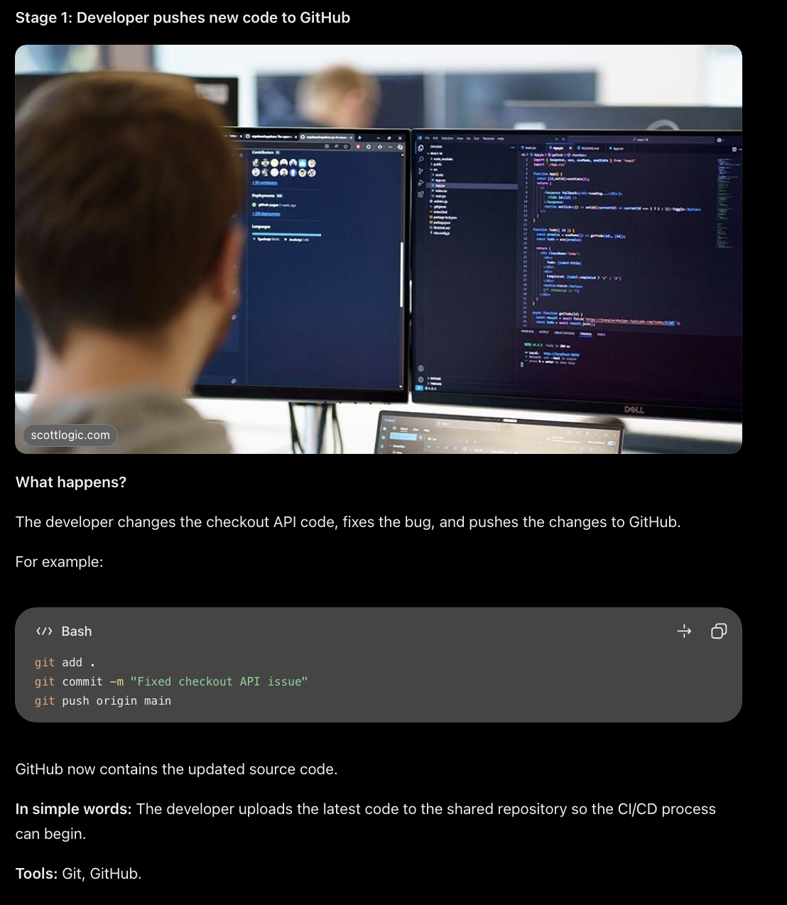
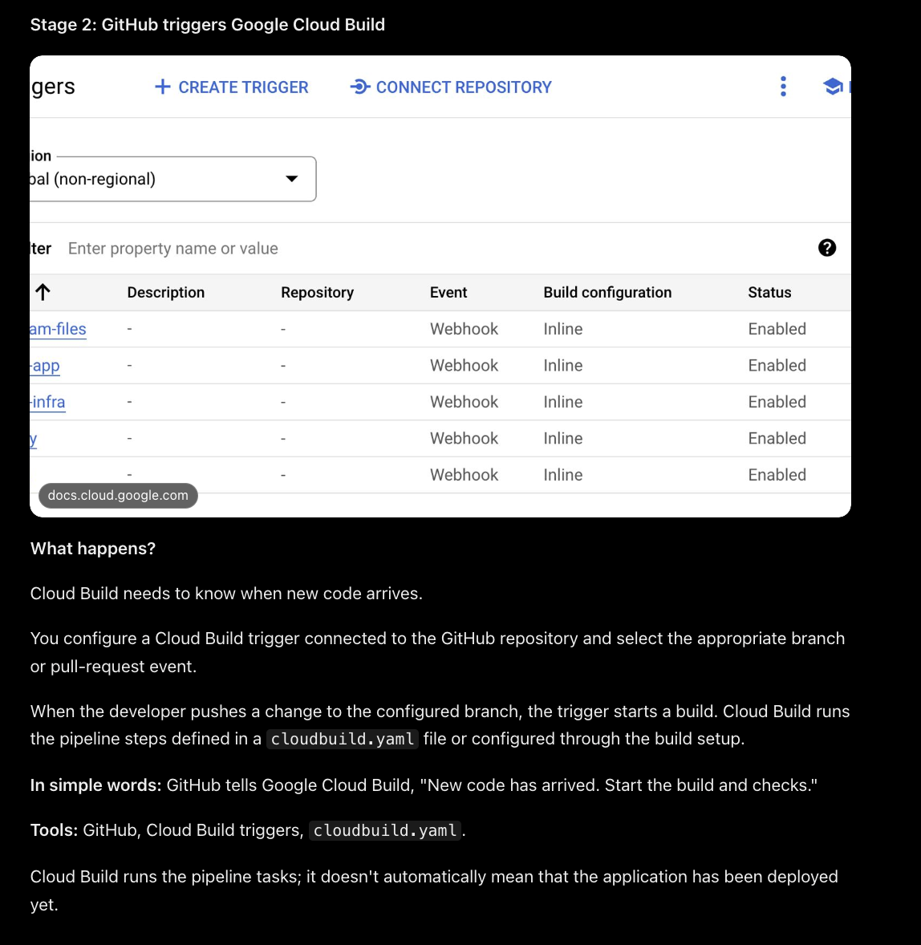
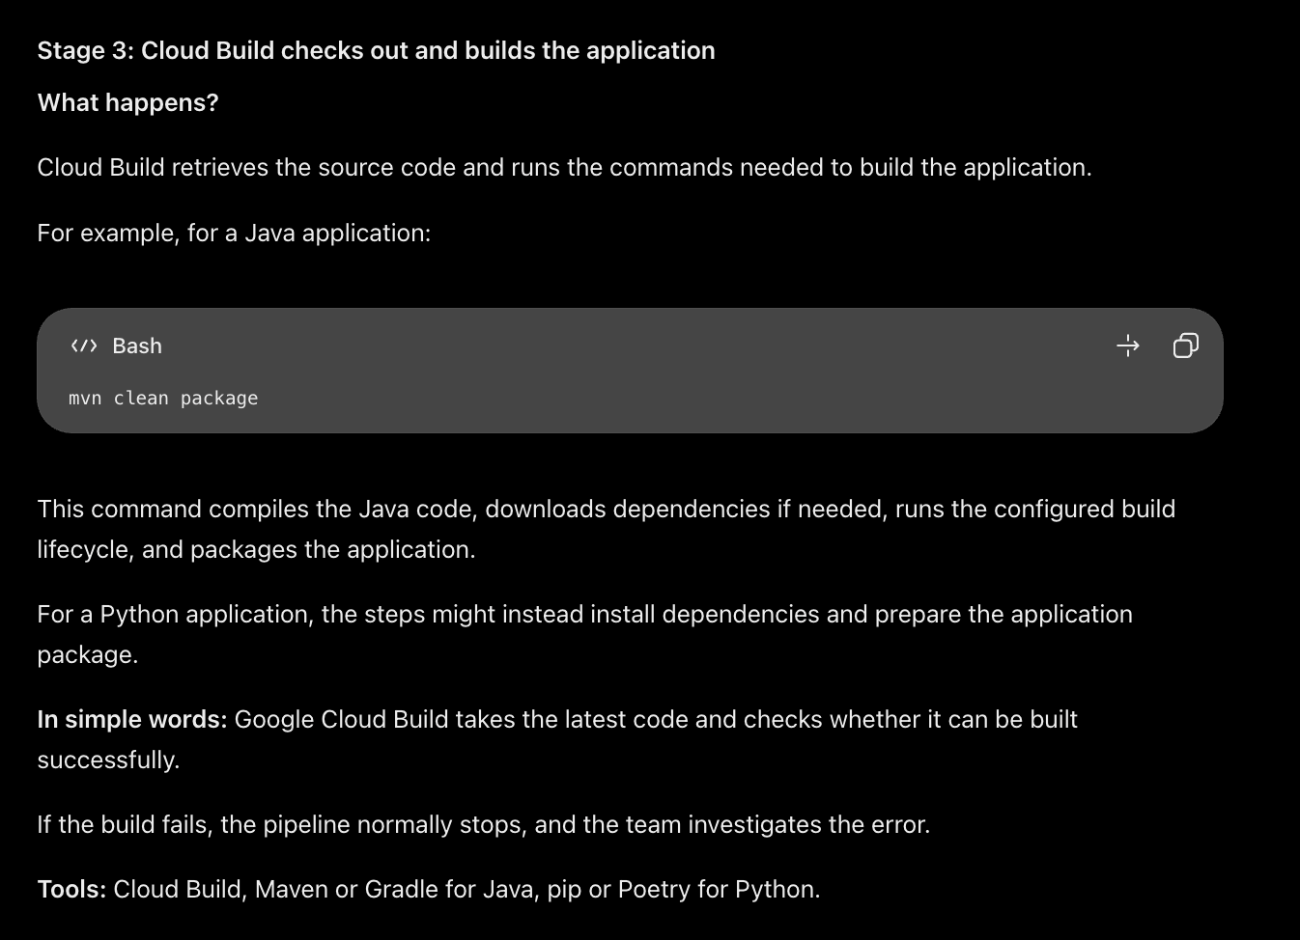
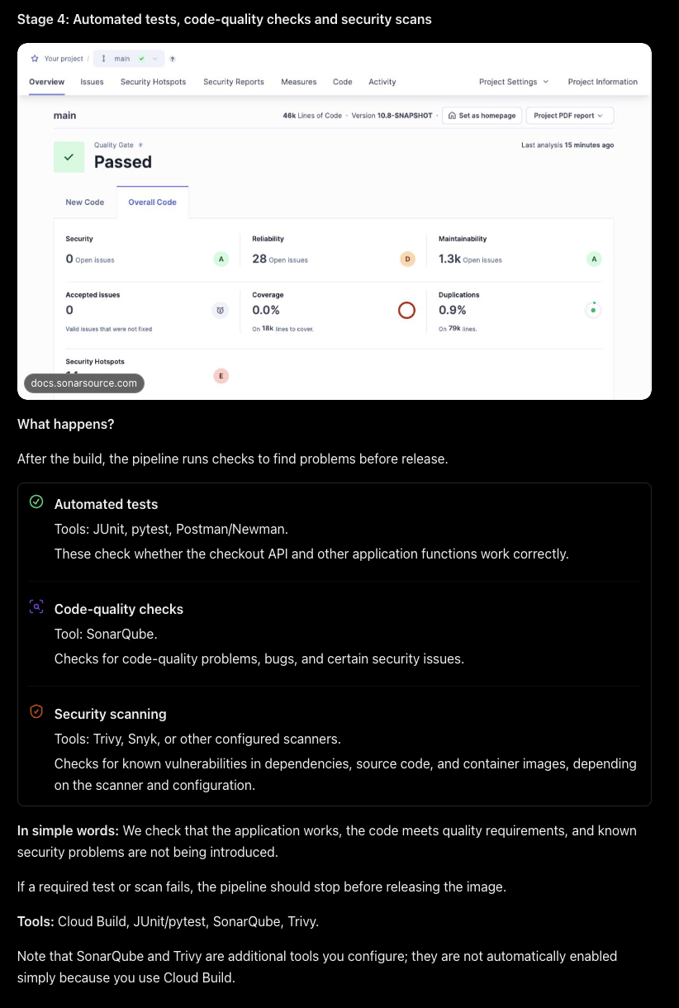
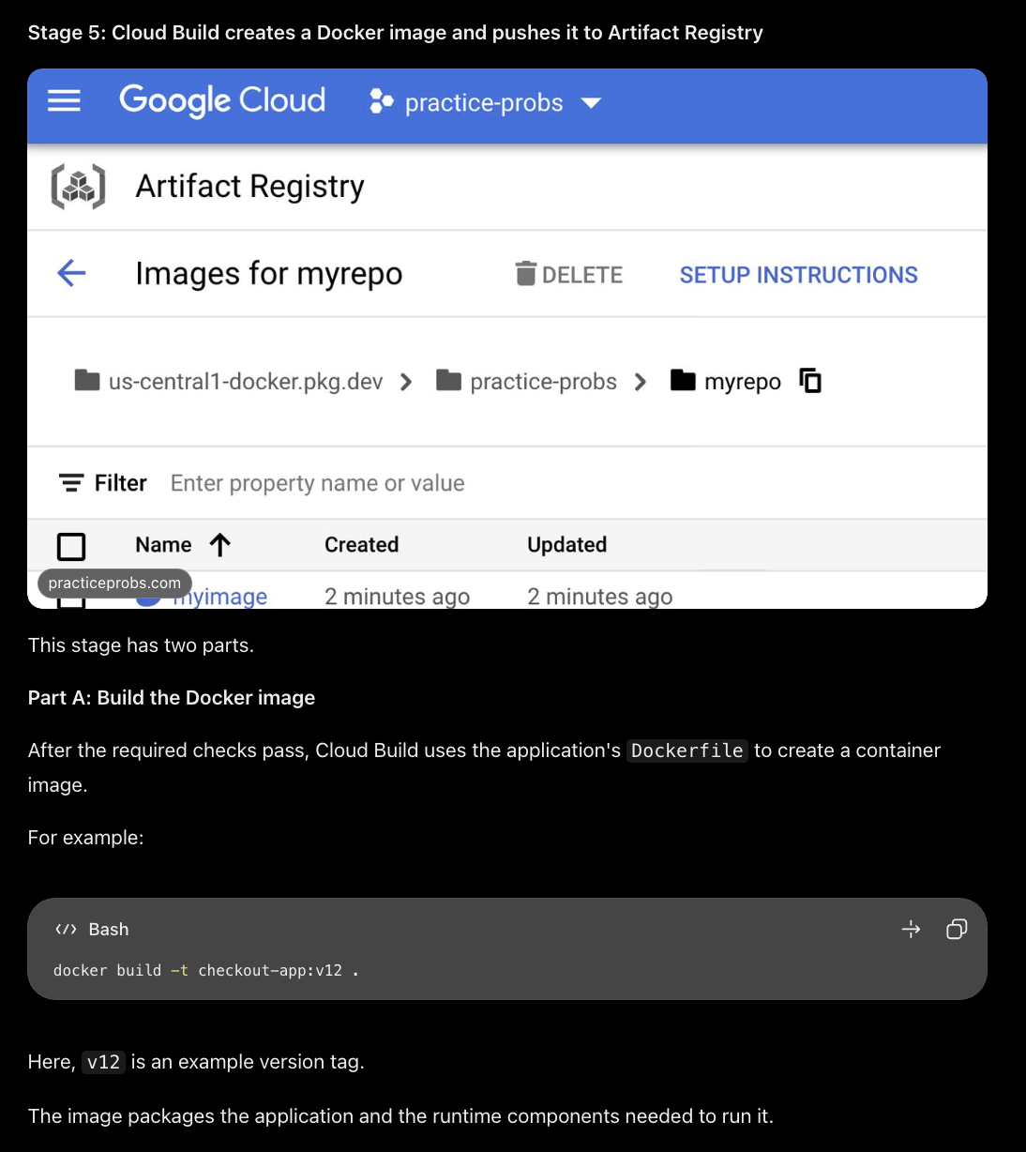
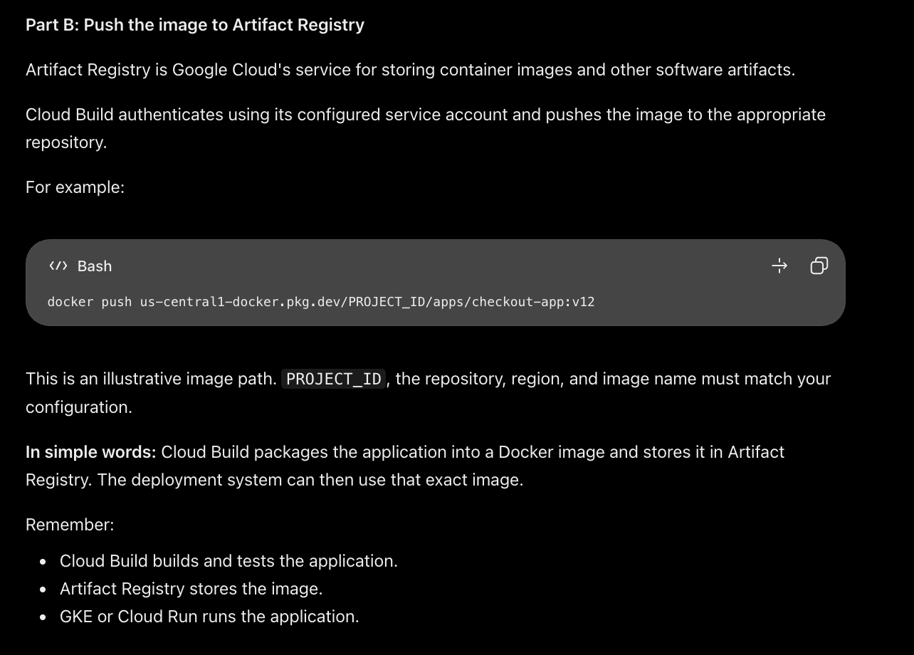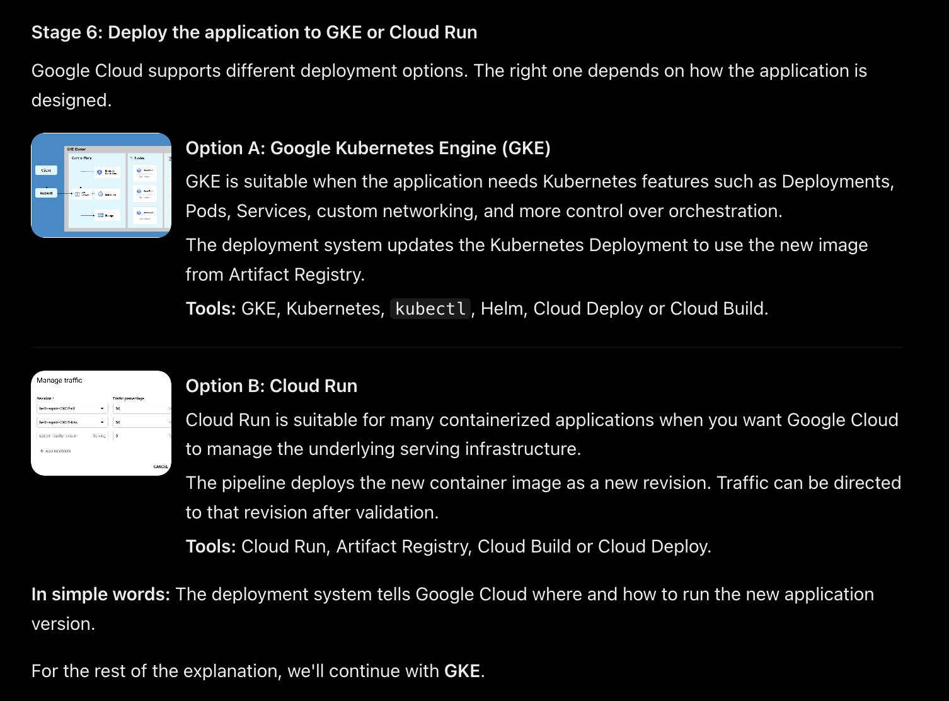
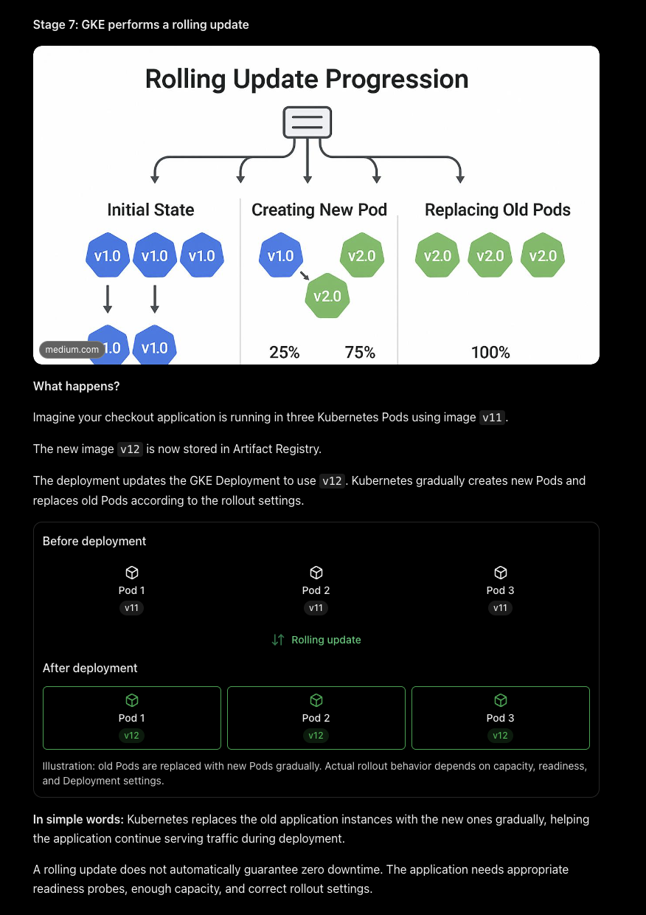
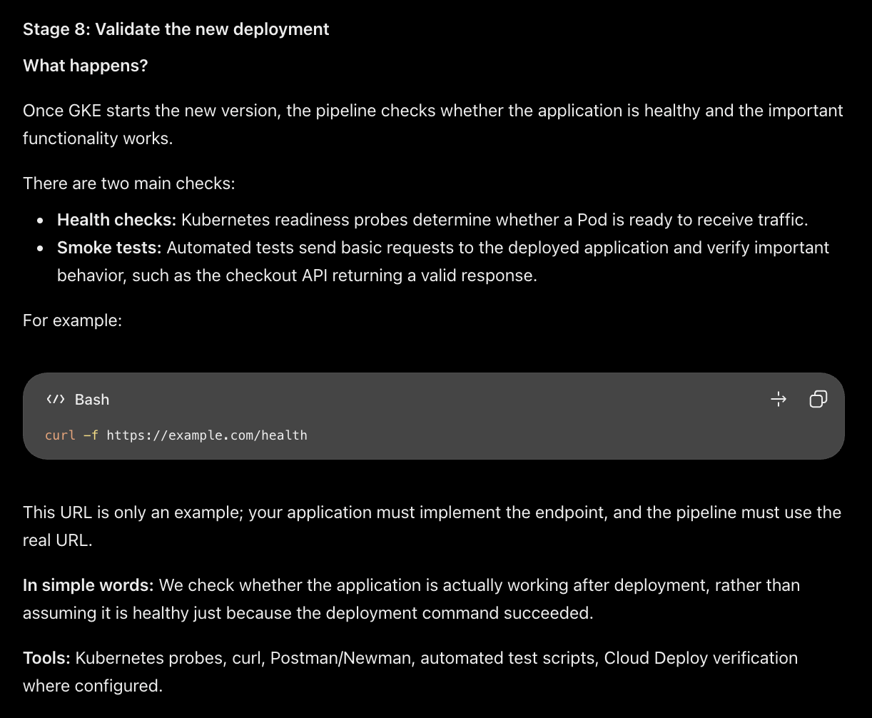
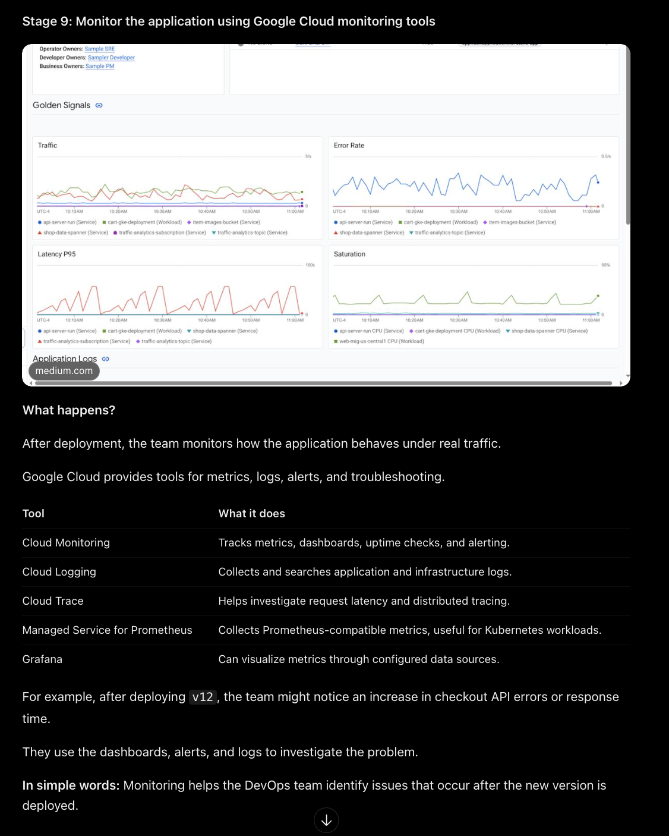
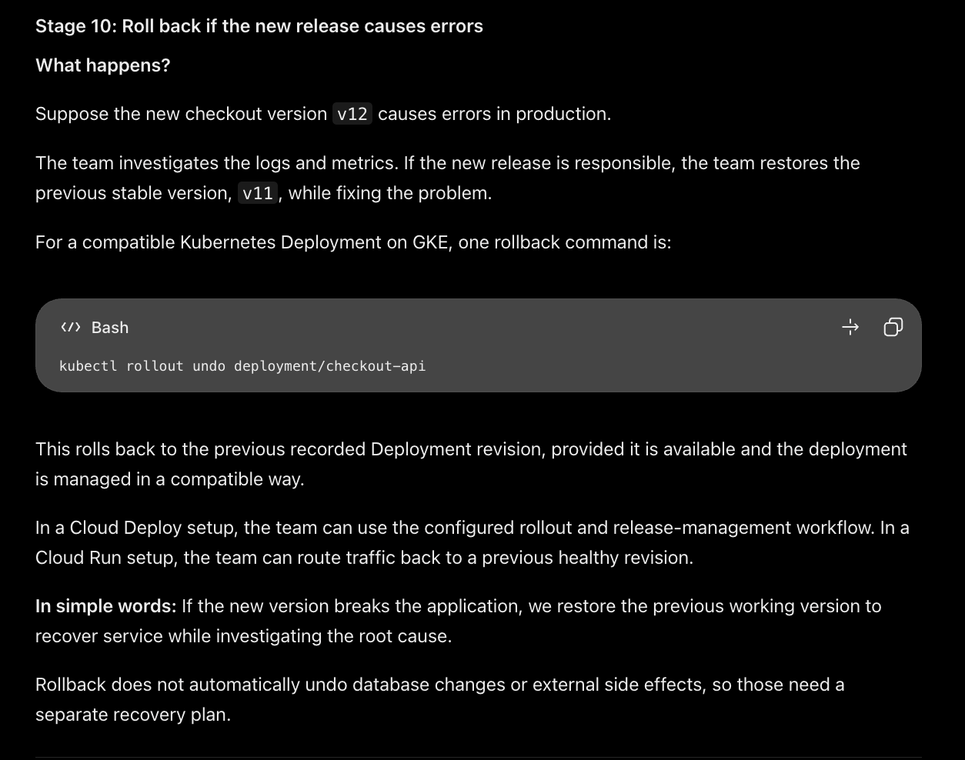
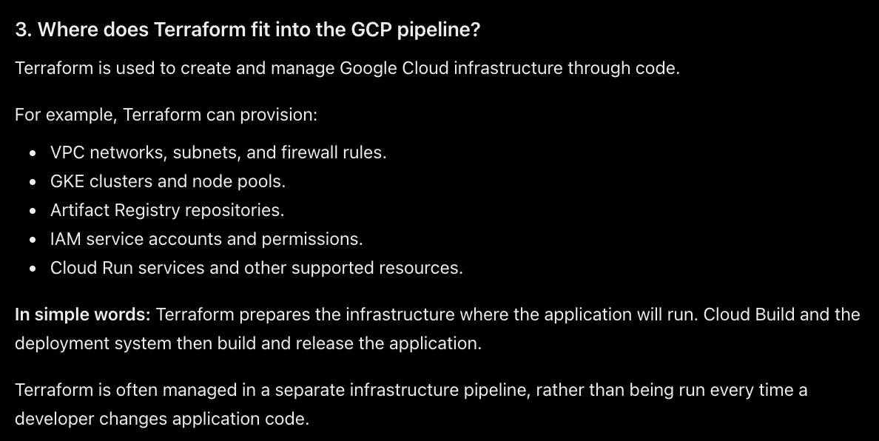
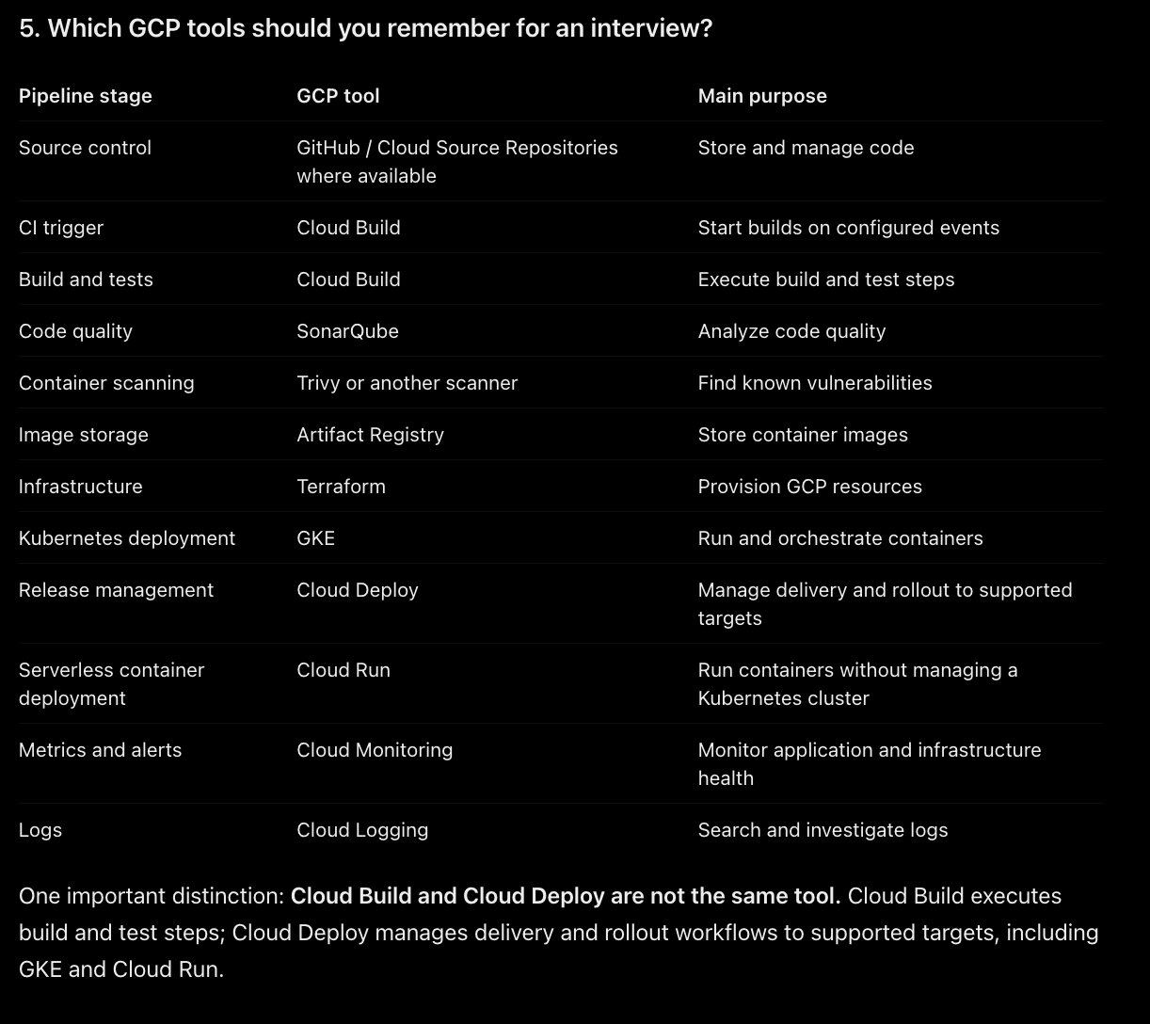
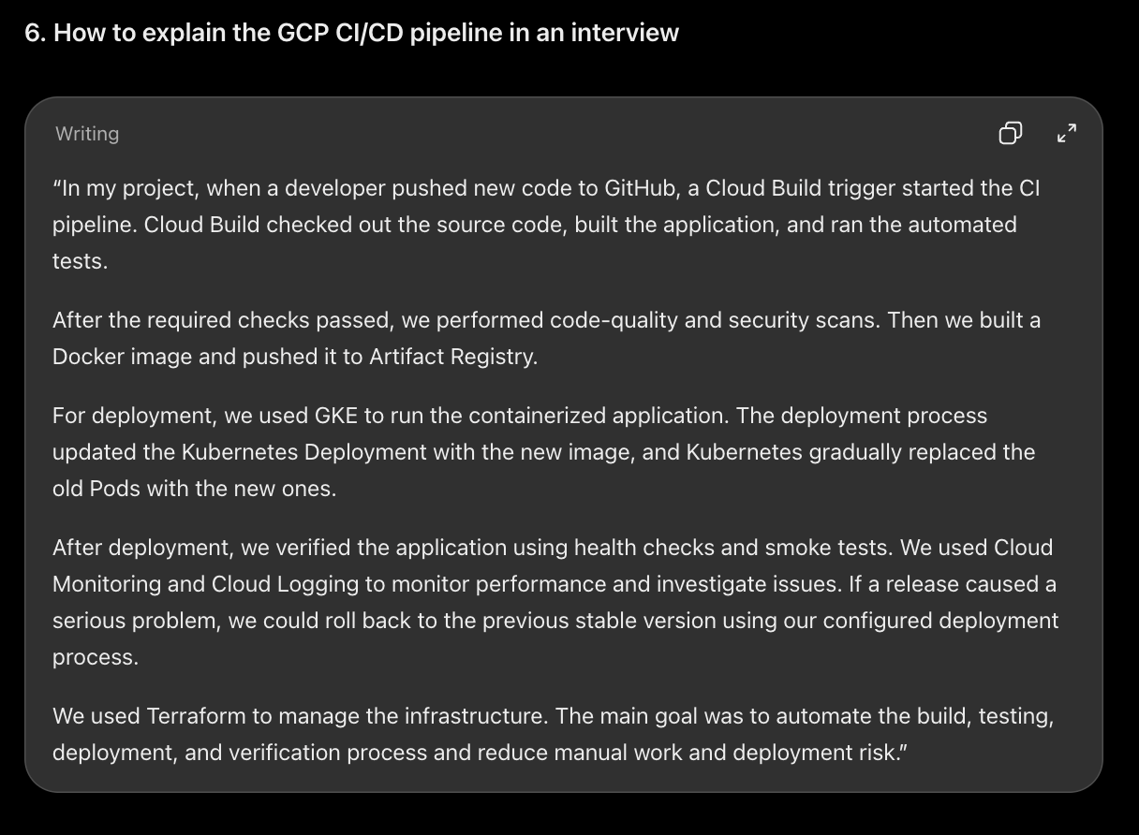
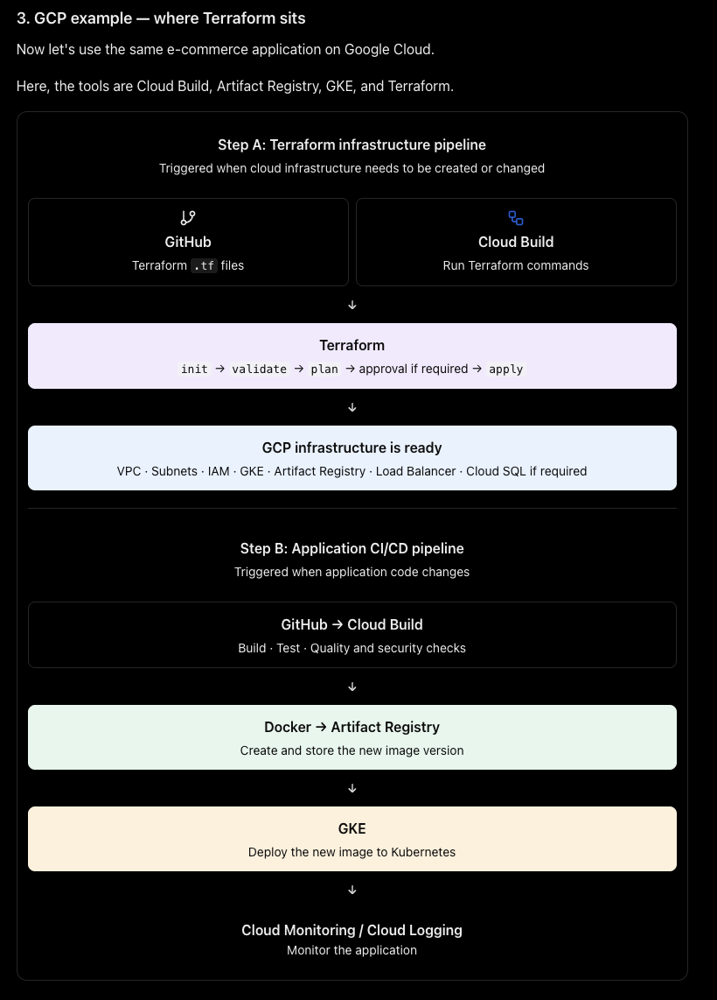
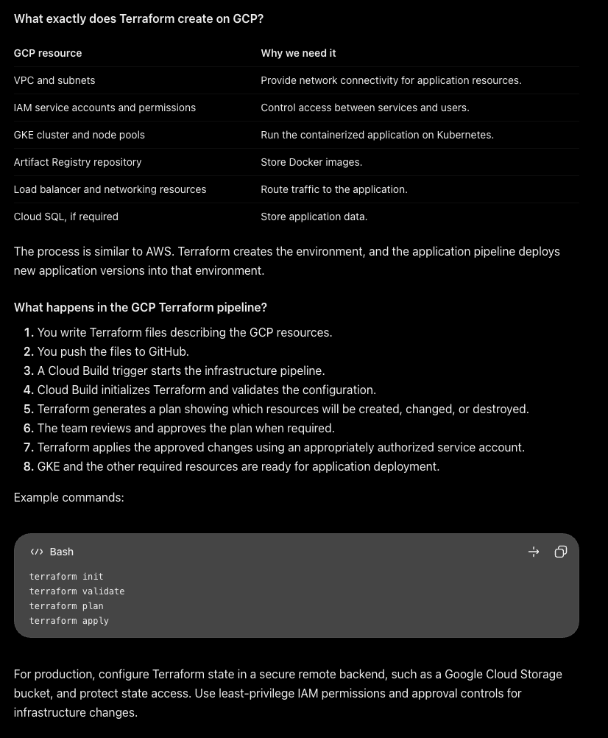
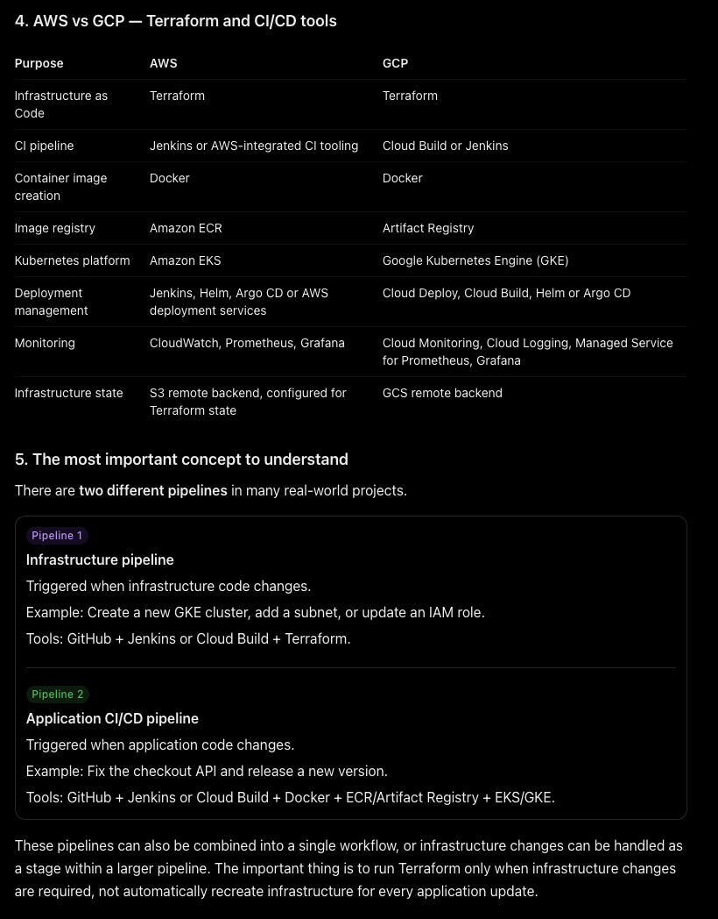

“In my project, we used Terraform to manage our cloud infrastructure. We maintained the Terraform configuration files in GitHub, and when infrastructure changes were required, we ran a separate pipeline to validate the configuration, review the plan, and apply the changes.
For AWS, Terraform managed resources such as VPCs, IAM roles, EKS clusters, and other required services. For GCP, it managed resources such as VPCs, IAM permissions, GKE clusters, and other cloud services.
Once the infrastructure was ready, our application CI/CD pipeline handled the application code. It built and tested the code, created a Docker image, pushed it to the container registry, and deployed it to Kubernetes.
We did not need to recreate the infrastructure every time a developer changed the application code. We used Terraform whenever the infrastructure needed to be created or updated.”

